AAI 500 Midterm Student Exam
  - Interpreting Statistical Evidence
Weeks 1 to 5 | 120 minutes | 170 points | 15% of the course grade
Student name: Justin Nguyen Date: 10/09/2026
Interpret completed evidence in six situations. Each case has two responses. Read the scenario, supplied definitions, graphs and completed output, then explain the decision or interpretation requested. You do not need to write code or create graphs.
Cases 1 to 5 use instructional scenarios adapted from the homework. Case 6 uses completed outputs from the Week 5 classroom exercise. Artificial intelligence is abbreviated AI.

Plan your time
Use 15 minutes to read and plan, 90 minutes for the cases, and 15 minutes to check your work. You may redistribute the suggested case times.
Case | Suggested minutes | Points
1 | 12 | 24
2 | 15 | 28
3 | 18 | 32
4 | 15 | 28
5 | 15 | 28
6 | 15 | 30

Exam instructions
Resources Follow the course and University guidelines for permitted resources, including AI usage.
Responses Answer the decision or interpretation requested. Cite a relevant number or graph feature and explain how it supports your answer. Address a limitation when the question asks for one.
Output All statistics needed for your answers are supplied. Use the rounded output. No code, new graphs, or additional statistical calculations are required.
Submission Complete and submit your responses in this Word document.
Most answers will fit in 1-2 complete paragraphs This is guidance, not a minimum. A complete, accurate shorter answer can receive full credit.
Credit rewards an accurate conclusion, relevant evidence, and a correct explanation. Where requested, also explain the limit or next step. Correct statistical meaning matters more than polished prose.
Replace each response placeholder with your answer. The response space expands as you type.

Case 1 The Enrollment Help Desk
24 points | Suggested time 12 minutes | Week 1
During the first week of enrollment, a university uses an AI assistant to draft replies to routine questions. A staff member checks each draft before sending it. The service promise is that at least 90% of questions receive a checked reply within 10 minutes. An analyst randomly selects 100 questions from that week’s full ticket log. Response time runs from receipt of a question to the checked reply; it includes waiting in the review queue. Each ticket contributes one observation. The completed histogram and summary describe this sample. A few long delays are verified records, so they remain in the analysis.
Terms Mean: arithmetic average. Median: middle response time. Each histogram bar counts tickets in its time range.
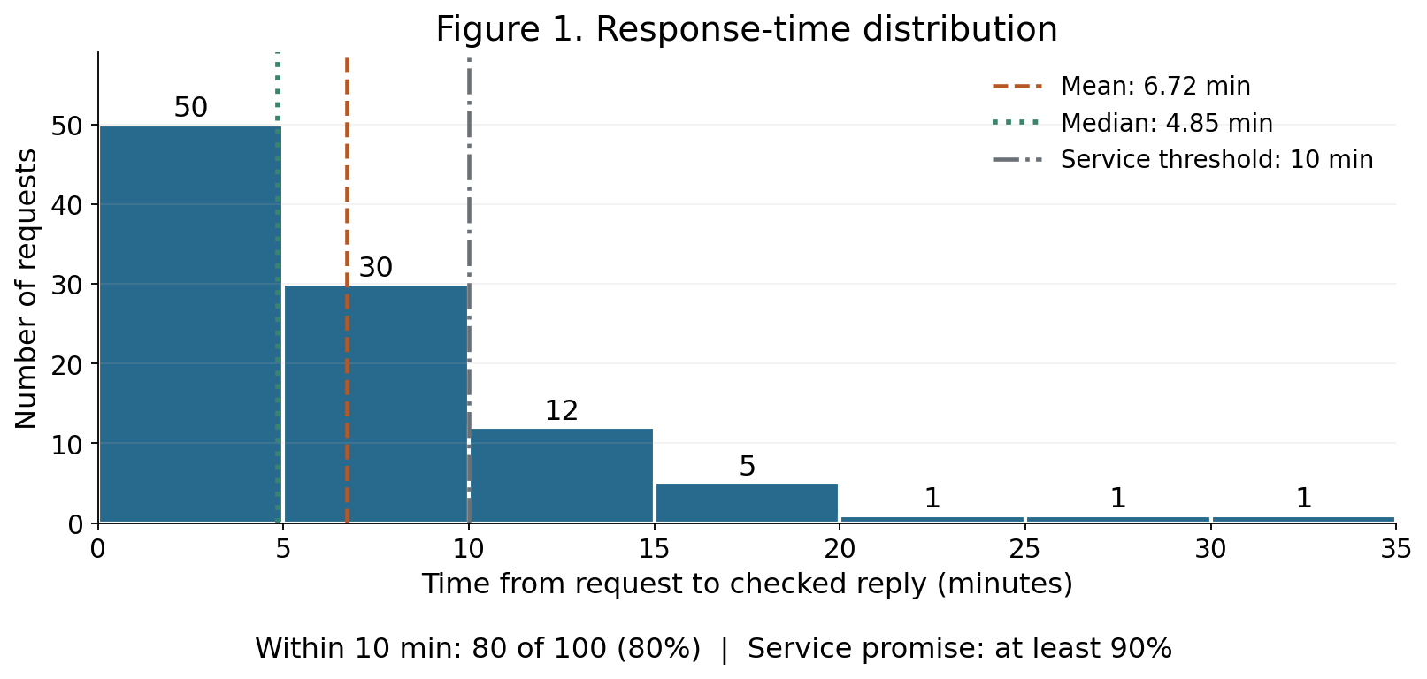

Question 1.1 12 points
Which summary, the mean or the median, better describes a typical ticket’s response time? Use the histogram shape and both reported values. Explain why the verified long delays should remain in the data.
Suggested response length: 1-2 complete paragraphs
The median would better describe a typical ticket's response time. The response time is right-skewed meaning that most tickets/questions receive checked replies within 10 minutes (80%) while few take longer than 10 minutes (20%). The mean is also less resilient to outliers and 20% of the observations inflate the mean above what users would typically experience. Verified long delays should remain in the data since they are real ticket response times and not misinputed data. Removing the long delays would artificially produce a favorable distribution and would reduce the integrity of the sample.

Case 1 The Enrollment Help Desk Continued
24 points | Suggested time 12 minutes | Week 1

Question 1.2 12 points
The service manager must decide whether this sample meets the promise of at least 90% of replies within 10 minutes. What should the manager report, and can the mean response time alone answer that question? Cite the supplied percentage and explain the scope of your conclusion.
Suggested response length: 1-2 complete paragraphs
The mean (6.72) alone cannot answer the question. The manager should report the sample size (100), the success percentage of the sample (80% of tickets answered within 10 minutes), the median of the sample (4.85) since this is what users would typically experience, the mean (6.72) and explain how the 3 outliers make it not reliable. Also they should explain that the 3 outliers are verified records and not misinputed data and that this is only covers 100 tickets and not the entirety of the responses.

Case 2 A Week at Riverside Emergency Department
28 points | Suggested time 15 minutes | Week 2
Riverside’s emergency department is planning staffing for the next month. The chart shows the number of arrivals on each day of one observed week, from Sunday through Saturday. All days cover the same 24-hour period and all arrivals are counted. An analyst proposes using one Poisson distribution with the same mean, 23.4 arrivals per day, for every day of the week. The proposal assumes that the daily arrival rate is stable and arrivals occur independently. The staffing manager wants to know whether these seven observations support that choice and whether the high Friday and Saturday counts will recur.
Terms Poisson: counts of events in a fixed period under a stable rate and independent arrivals, with equal theoretical mean and variance. Normal: a continuous, symmetric, bell-shaped distribution. Gamma: a continuous distribution for positive measurements, often with right skew. Variance describes spread in squared count units. A small sample’s mean and variance need not match exactly, even for Poisson counts.
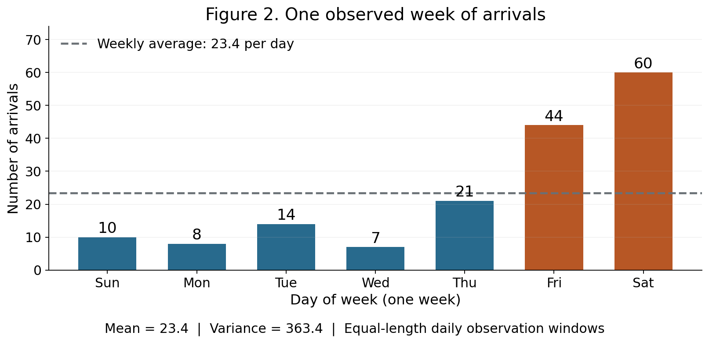
Completed output note: the descriptive variance divides by 7.

Question 2.1 16 points
Choose a starting distribution for the number of arrivals in a fixed 24-hour period from the three supplied descriptions. Then decide whether using one Poisson distribution with the same mean for every day is well supported by this week’s evidence. Use the kind of variable, the daily pattern, and the reported mean and variance.
Distribution | Description
Poisson | Whole-number counts in a fixed period
Normal | Continuous measurements with a symmetric bell shape
Gamma | Positive continuous measurements, often with right skew

Suggested response length: 1-2 complete paragraphs
Mean = 23.4, Variance = 363.4. The Poisson distribution is the correct distribution for this kind of problem since it is measuring the number of events happening in a fixed time frame. Using the same mean for the entire week is not supported by the evidence due to the spike of hospital visits on Friday and Saturday. This breaks the Poisson distribution's stable rate assumption and is further reinforced by dividing the variance by the mean (363.4/23.4 = 15.5).

Case 2 A Week at Riverside Emergency Department Continued
28 points | Suggested time 15 minutes | Week 2

Question 2.2 12 points
Would you use this chart to make a permanent Friday and Saturday staffing increase for next month, or treat the increase as a provisional plan? Explain what the observed week supports, what remains uncertain, and one specific comparison that would improve the decision.
Suggested response length: 1-2 complete paragraphs
I would not use this chart to make a permanent Friday and Saturday staffing increase. This observation is for one week only and would support a short term staffing increase at most. This observation does not represent the entire month or year and would not be enough evidence to support a permanent Friday and Saturday staffing increase because it does not take into account external factors that could contribute to the increase of these events such as holidays, paydays, etc. I would compare the Friday and Saturday hospital visits over 4+ weeks and if there is consistency in the number of visits on these days then there may be enough evidence to support a permanent staffing increase for these days.

Case 3 The Blind AI Reply Preference Study
32 points | Suggested time 18 minutes | Week 3
A university compares two AI-generated answers to the same support question. Each randomly selected user sees both answers, with the labels hidden and display order randomized, and selects one preferred answer. Each user votes once. Two independent studies use the same procedure and target user population: 30 of 50 users choose B in the small study, and 240 of 400 choose B in the large study. Both studies therefore observe 60% preference for B. Figure 3 gives completed sampling distributions for the no-preference assumption: in the population, each answer has a 50% chance of being preferred. Each bar represents how likely a sample preference percentage would be under that assumption.
Terms Null assumption: 50% of users prefer B. Shaded tail: probability of getting the observed percentage or higher under that assumption. Use the preselected 5% rule for strong evidence against no preference. Standard error describes the spread of possible sample percentages, not the spread of individual preferences.
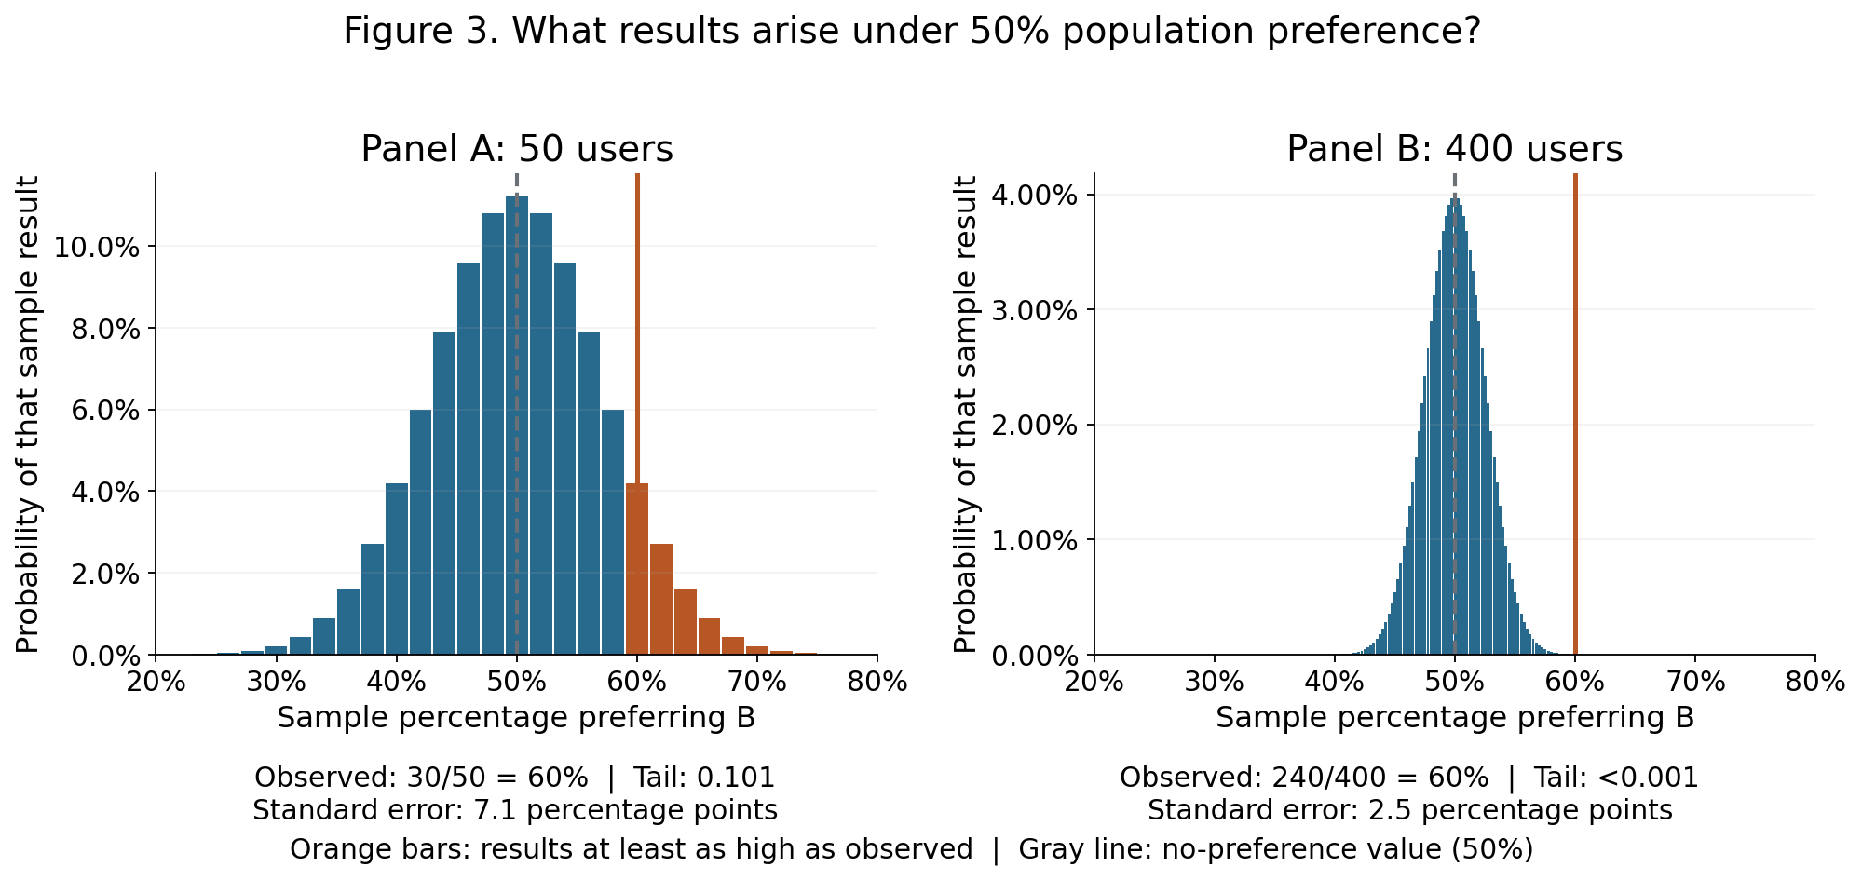

Question 3.1 16 points
Note: We are referring to both Panel A/B and AI-generated answers that refer to A/B. Ensure that you keep the notation separate in analysis.
Using Panel A and the preselected 5% rule, what can you conclude about whether a majority of the target population prefers B? Explain the meaning of the shaded tail probability. Also state whether this result establishes equal preference in the population.
Suggested response length: 1-2 complete paragraphs
Assuming that our null assumption is true, Tail = 0.101 meaning that there is a 10.1% chance of there being 60% or more of the sample preferring B and with 10.1% being greater than 5%, seeing 60% or more of the sample preferring B would not be uncommon. This does not give strong evidence against no preference, in other words, we fail to reject that 50% of users prefer B. However, this result does not establish that there is equal preference in the population.

Case 3 The Blind AI Reply Preference Study Continued
32 points | Suggested time 18 minutes | Week 3

Question 3.2 16 points
Which study gives stronger evidence of a population preference for B? Explain using the widths of the null sampling distributions and the observed preference percentages. Does the stronger study also show a larger observed advantage for B?
Suggested response length: 1-2 complete paragraphs
Panel B gives stronger evidence of a population preference for B. Since the distribution is approximately normal, we can use to emperical rule to say that all or almost all of the observations fall within 3 standard deviations from the mean. Since the standard error for panel A is 7.1 we can take 7.1 x 6 = 42.6 to get the full width of the distribution. The width is 42.6% centered on 50% whereas panel B has a width of 15% (2.5x6) centered on 50%. The observed percentage for panel B was 60% and is the same for panel A, if we take the observed percentage and subtract the assumed population preference (50%) and divide by the standard error we get (60% - 50%)/7.1 = 1.41 standard errors away from the mean for panel A and (60% - 50%)/2.5 = 4 standard errors away from the mean for panel B. This shows that the observed percentage for panel B is far from the center relative to its narrow standard error. The observation in panel B has a tail of .001 which is less than .05 meaning the chance of this outcome happening is very unlikely and that we reject the null assumption that there is no preference. Panel B does not show a larger observed advantage for B since both observed percentages are 60%.

Case 4 The Review-Time Recording Error
28 points | Suggested time 15 minutes | Week 4
An operations team wants to estimate the population mean time staff spend checking routine AI drafts. It randomly selects 10 independent reviews from one stable review process. Times are rounded to whole minutes; 0 means less than half a minute. The completed analysis reports a 95% confidence interval for the population mean, using a t interval. An import error changed the final record from 4 minutes to 24 minutes. An audit of the original log verifies that 4 minutes is correct. Figure 4 shows the individual records and the two completed analyses. The two rows are the same sample before and after correction, rather than two separate studies.
Terms A confidence interval for a population mean estimates the process average. A wider interval indicates less precision. Points in Figure 4A are individual review times.
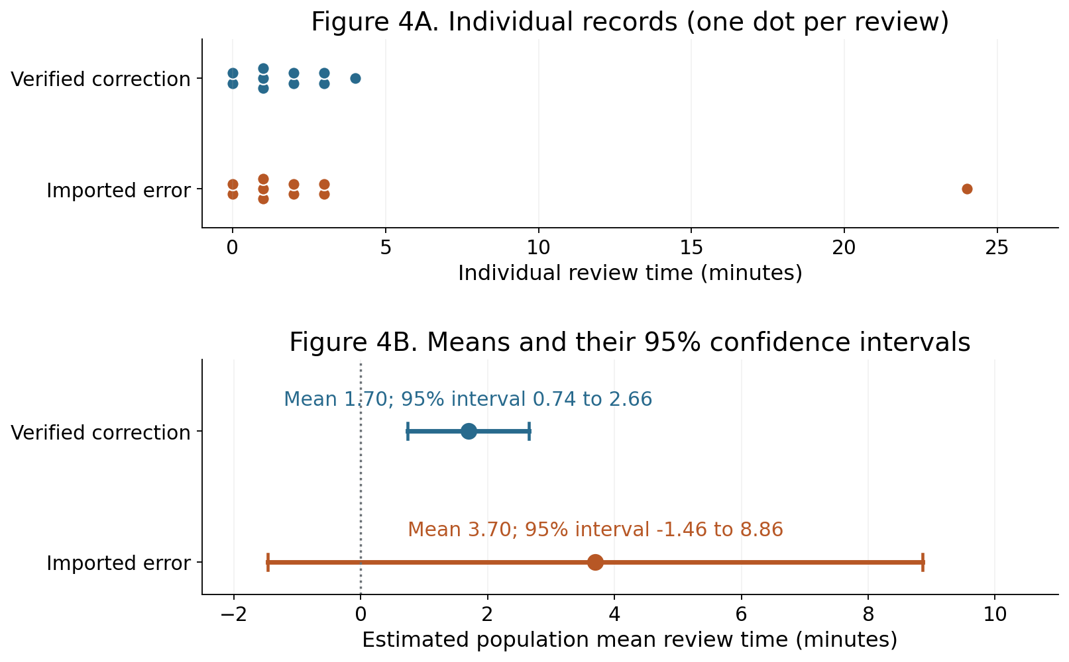

Question 4.1 14 points
Which completed analysis should the team use after checking the original log? Explain how correcting 24 minutes to the verified 4 minutes changes the estimated population mean and its precision. Use both reported intervals.
Suggested response length: 1-2 complete paragraphs
The team should use the corrected analyses because the imported error turned a record from 4 to 24 creating an outlier inflating the mean from 1.70 to 3.70 and widening the confidence interval from [0.74, 2.66] to [-1.46, 8.86] leading to less precision. The distribution of the analyses with the imported error also includes impossible values in the confidence interval (a review process cannot take negative minutes).

Case 4 The Review-Time Recording Error Continued
28 points | Suggested time 15 minutes | Week 4

Question 4.2 14 points
The manager needs an estimate of the process average and also wants to see the variation among individual reviews. Which display answers each need? Use the corrected interval and the individual-time plot, and explain why the interval cannot be read as a range containing 95% of individual reviews.
Suggested response length: 1-2 complete paragraphs
Assuming that we can choose two figures, figure 4B answers the process average need by displaying the mean and figure 4A answers the variance need by plotting each individual review so that variance is visible. The 95% confidence interval for the corrected analysis is not saying that 95% of the individual reviews will fall into this range, what it is saying is that if you were to take many samples and calculated the interval the same way each time, 95% of those intervals will contain the true mean so while the interval measures the precision of the mean, this interval does not measure individual review times.

Case 5 Feedback on the Campus AI Tutor
28 points | Suggested time 15 minutes | Week 4
A university pilots an AI tutor and invites students to rate one session as negative, neutral or positive. Three hundred students volunteer, with one rating per student. The team groups responses by the device used for that session: Android, iOS or desktop. Figure 5A displays percentages within each device group, alongside the underlying counts. The completed chi-square test asks whether device and rating are associated. Figure 5B shows the counts expected under no association. These are expected counts, not observed ratings. The desktop group has only 9 responses. Device was not randomly assigned, and the survey consists of volunteers.
Terms Within-group percentage: count divided by that device’s total. A chi-square test compares observed counts with counts expected under no association. The supplied p-value uses a large-sample approximation. Use the preselected 5% rule when assessing evidence. Expected counts below 5 can weaken this approximation.
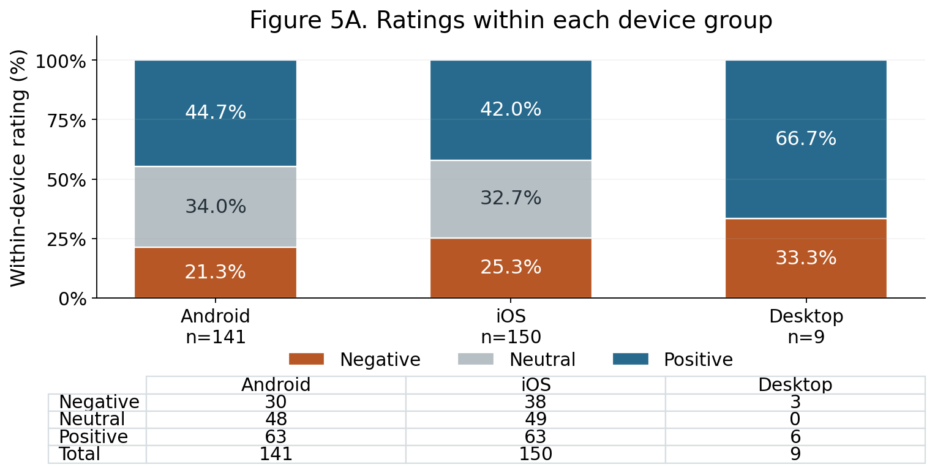

Question 5.1 12 points
Compare the positive-rating percentages for Android and iOS using Figure 5A. Explain why the equal counts of 63 positive ratings do not settle that comparison. Would these results justify requiring all students to use the device with the higher percentage? Give one relevant limitation of this survey.
Suggested response length: 1-2 complete paragraphs
Total number of android users = 141, total number of IOS users = 150. 63/141 = 44.7% of android users giving a positive rating compared to the 63/150 = 42% of IOS users giving a positive rating. While android and IOS have an equal count of positive ratings, the percentage of positive ratings compared to total number of ratings is different which is why equal counts of positive ratings does not settle the comparison. The results would not justify requiring all students to use the device with higher percentage because this survey only shows an association and not causation as well as the difference between the two groups in positive ratings is only 2.7%. One limitation to this survey is that the selection of subjects is not completely random, these subjects volunteered for this survey so this could only represent a population who are interested in this topic and not the entire student body.

Case 5 Feedback on the Campus AI Tutor Continued
28 points | Suggested time 15 minutes | Week 4
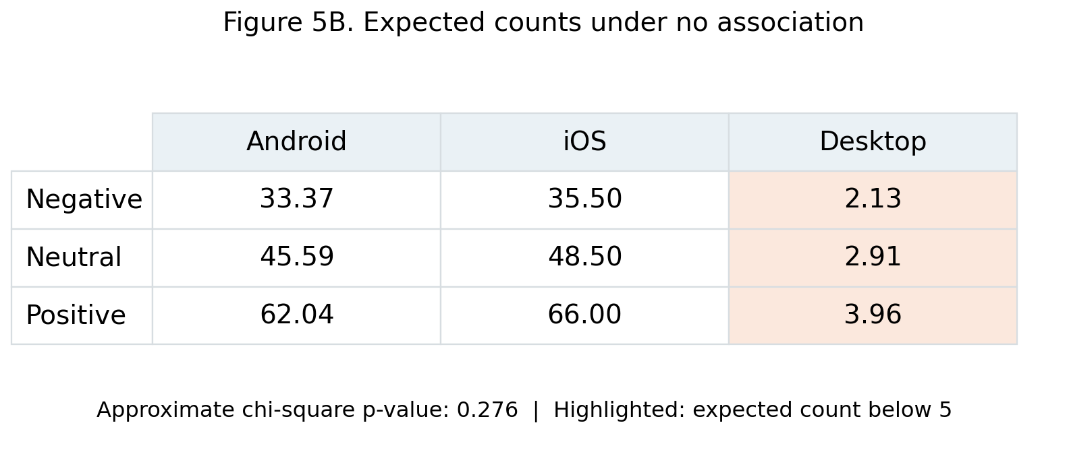

Completed test output
Measure | Result
Chi-square statistic | 5.116
Degrees of freedom | 4
Approximate p-value | 0.276
Expected cells below 5 | 3 of 9

Question 5.2 16 points
What conclusion about an association between device and rating can the team defend from the supplied test? Use the p-value, the 5% rule, and the highlighted expected counts. Explain what the result does and does not establish.
Suggested response length: 1-2 complete paragraphs
The null hypothesis is that there is no association between device and rating. P = .276 which is greater than .05 so we fail to reject the hypothesis that there is no association between device and ratings. The result establishes that we do not have strong of enough evidence of association between device and rating, however, it does not establish that there is no association between the two. 3 of 9 of the cells are below 5 with all 3 of the cells belonging to the desktop group. This is likely due to the low student volunteer count for this group.

Case 6 Interpreting the Heart-Disease Network
30 points | Suggested time 15 minutes | Week 5
In the Week 5 classroom exercise, an analyst fits a Bayesian network to retrospective patient records. The recorded target is heart disease present or absent. The network supplies a probability of heart disease for a specified set of observed patient characteristics. Figure 6A charts completed query outputs from the course answer key. Profile A conditions on an older age category and a flat ST-slope category; Profile B adds exercise-induced angina for the same profile. The analyst also predicts disease when the estimated probability exceeds 50%. Figure 6B shows how the reported 81.7% accuracy was obtained: the network was fitted and evaluated using the same full set of records. No separate test sample was used.
Terms Bayesian network: a probabilistic representation of relationships among variables. ST slope: a recorded exercise-test category. Exercise-induced angina: chest discomfort during exercise. Accuracy: percentage of classifications matching recorded labels. The older age category means over 65 years old.
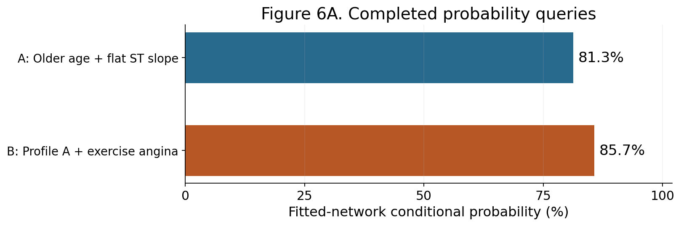

Completed classification output
Measure | Result
Conditional estimate change | 81.3% to 85.7%, an increase of 4.4 percentage points
Positive classification rule | Estimated probability >50%
Reported accuracy | 81.7%
Evaluation records | Same full records used for fitting

Question 6.1 14 points
How does adding exercise-angina evidence change the network’s estimate for the same patient profile? Interpret the two probabilities in Figure 6A and explain what the 85.7% estimate tells us about this individual’s disease status.
Suggested response length: 1-2 complete paragraphs
Adding exercise-angina to profile A increases the conditional estimate by 4.4 percentage points, only a small amount since the evidence before adding exercise-angina was already a high estimate. P(disease | evidence) = 81.3%, P(disease | evidence + exercise-angina) = 85.7%. It means that among patients with this evidence, 85.7% of them have heart disease.

Case 6 Interpreting the Heart-Disease Network Continued
30 points | Suggested time 15 minutes | Week 5
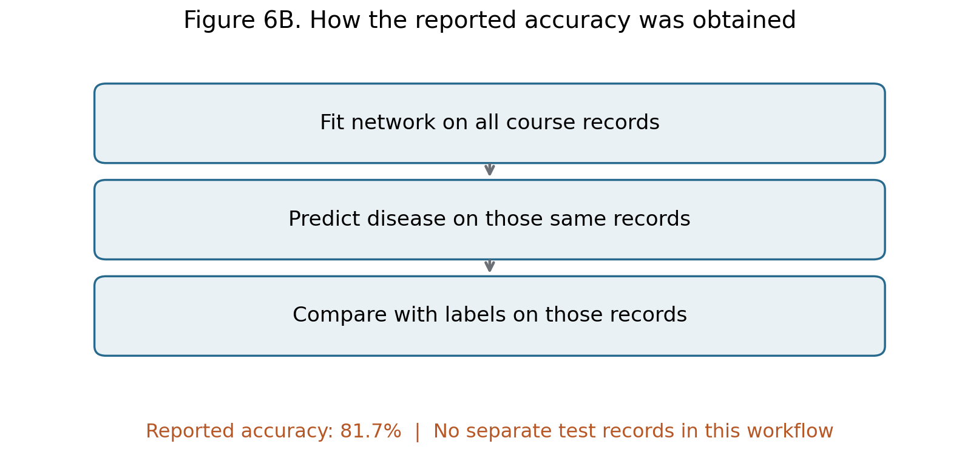
Completed classification output: positive when estimated probability >50%; accuracy 81.7%; evaluation uses the same full records used for fitting.

Question 6.2 16 points
The team must decide whether the reported 81.7% accuracy is enough evidence to use this network for new patients. What would you recommend based on Figure 6B? Explain the problem with the evaluation workflow and specify the next validation step.
Suggested response length: 1-2 complete paragraphs
The problem with this workflow is that the test and training data are not separated, this model is trained on all the records and is tested on all the records which likely exaggerates the accuracy. I recommend splitting the course records into training and testing data and fit the network on the training data then predict the testing data. As it stands, the 81.7% accuracy is likely exaggerated because it is tested on the same records that it is trained on so I would not use this network for new patients.

Before submitting
Check that all 12 responses are complete. Each conclusion should use the requested evidence and refer to the correct sample, group or statistical quantity.

Preparation sources
AAI 500 Assignments 1.1–5.1 and supplied answer keys, by Leon Shpaner and Dallin Munger where credited. Cases 1–5 adapt their statistical tasks; Case 6 charts the supplied Week 5 conditional-query output. All adapted scenarios and practice data are instructional.
Preparation credit: ChatGPT assisted with drafting, chart code, layout and consistency checks.

